The Tribe Of Levi
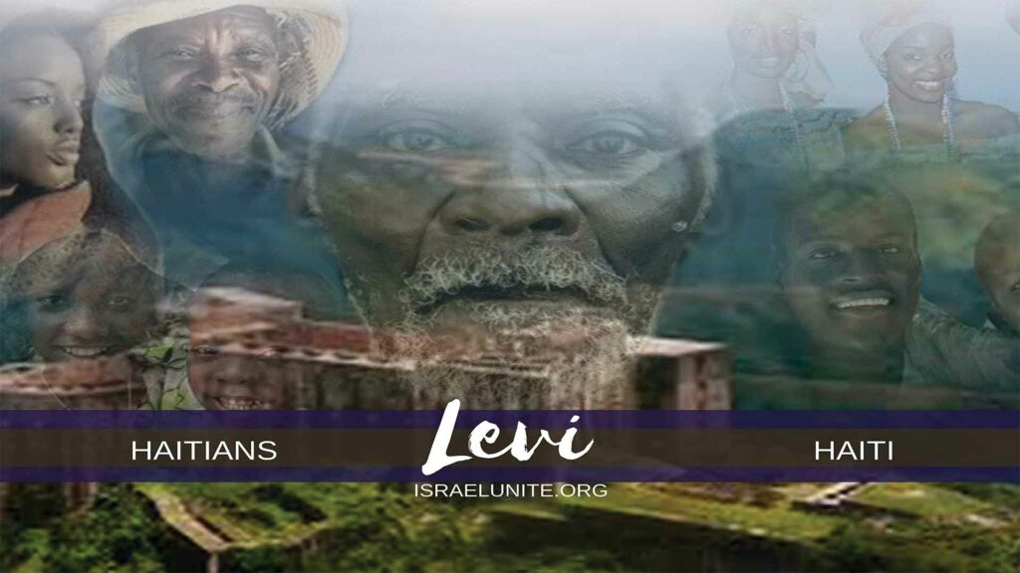

The tribe of Simeon was among the 10 tribes of Israel when they migrated to Arsareth/the Americas according to 2 Esdras 13:40-44. They inhabited the island of Hispaniola which we shall prove and were conquered by Spain in 1492.
In the 1600’s the tribe of Levi (Haitians), along with Judah and Benjamin, were sold into captivity (by the Africans and the Arabs), to the white-man. The white man then transported them in chains on slave ships to Haiti to serve hard bondage as slaves.
Genesis 49:1 “And Jacob called unto his sons, and said, Gather yourselves together, that I may tell you that which shall befall you in the last days.”
The last days occur from the days of Christ untill today. Read Hebrews 1:2.
Genesis 49:5. “Simeon and Levi are brethren; instruments of cruelty are in their habitations.”
“Simeon and Levi are brethren”, all Jacobs’ sons are brothers, the reason he specifies Simeon and Levi, are brethren is because in the last days they would dwell together in one place: The island of Hispaniola. “Instruments of cruelty are in their habitations”, meaning they are heavily involved in the use of witchcraft and the worship of Satan. In the past, Lev, was renowned for dealing with spiritual forces of the Heavenly Father (the priesthood), however, this scripture specifies “of cruelty” meaning spiritual forces of Satan: witchcraft. Their habitations are Haiti, and Dominican Republic. In Haiti, their instruments of cruelty is called “voodoo”. In the Dominican Republic, their instruments of cruelty is called “Brujeria”.
Genesis 49:6, “O my soul come not thou into their secret, unto their assembly mine honor, be not thou united: for in their anger they slew a man, and in their self-will they digged down a wall.”
“O my soul” meaning Israel, in Genesis 32:28, Jacobs’ name was changed to Israel. “Come not thou into their secret” meaning Israel, learn not the secret of their witchcraft. “Unto their assembly” is the dwelling together of these brothers in one place: Hispaniola (Dominican Republic and Haiti). Simeon and Levi, are the honor of Jacob, but “be thou not united” means although Simeon and Levi are brethren, assembled together, they would not be united. That is why on the island of Hispaniola, there is a division. On the eastern part of Hispaniola, you have the tribe of Simeon you’ll probably speak Spanish; in the west, you have the tribe of Levi where speak either French or Creole, a division that’s the result of centuries of European colonization and numerous power struggles. They have also time, economic and class differences.
“For in their anger they slew a man and in their self-will they digged down a wall”, the man they slew was Shechem an African prince. Their self-will was their furious determination against Jacobs’s wishes and the wall they digged down was the agreement Jacob, made with Hamor, King of the Hivites. This history is recorded in Genesis 34th chapter. Here’s a brief synopsis:
Jacob’s daughter Dinah, was raped by an African prince named Shechem. His father, named Hamor asked if Shechem and Dinah, could marry and form an alliance between the two people; to trade sons and daughters in matrimony and share their wealth with the inhabitants of the land. Jacob’s son replied deceitfully that the Hivites, the people of Shechem needed to be circumcised for the marriage to take place; they agreed. On the third day, the soreness of the circumcision set in and Simeon and Levi, got swords and then slaughtered every male of the city. This history correlates with another historical event that took place in Hispaniola:
“Black Indians” by W.L. Katz pg. 33.
“In 1522, Europeans in the Americas first learned that slavery did not easily lead to enormous wealth. On Christmas Day, African (Levi) and Indian (Simeon) slaves on a plantation owned by Diego Columbus rose and murdered their masters and overseers… The beautiful island of Hispaniola shook with the first recorded slave rebellion in the New World. The conspiracy had spread across the sprawling sugar plantations in the weeks before Christmas. Patiently the plotters (Simeon and Levi) waited until Christmas Day when the planters and their families would be bloated with food, soaked with liquor, and too weak or sleepy to offer much resistance. Then they struck, plunging into the night to kill whites and find freedom.”
Genesis 49:7, “Cursed be their anger, for it was fierce: and their wrath, for it was cruel: I will divide them in Jacob, and scatter them in Israel.” The Lord, divided and scattered the tribe of Levi, throughout all Israel. As the Levitical Priests, they had no inheritance of land, they were rather given the suburbs throughout all the cities of Israel, to dwell in
Deuteronomy 18:1-9 and Joshua 21:1-8
Deuteronomy 33:8 “And of Levi he said, Let thy Thummim and thy Urim be with thy holy one, whom thou didst prove at Massah and with whom thou didst strive at the waters of Meribah;”
“Let thy Thummim and thy Urim be with thy holy one”, the High Priest of Levi, were commanded in Exodus 28:30, to carry the Thummim and the Urim; which are similar to the crystal ball and stone that gave off colors, wherein the Most High, spoke to and instructed Israel. So Levi, is told to let their spiritual prowess be with the creator (thy holy one) opposed to their spiritual forces being with Satan, in voodoo. “Whom thou didst prove at Massah, and with whom thou didst strive at the waters of Meribah”, in Exodus 17:7, these areas were where Israel, complained for water and the Lord, commanded Moses, to smite the rock for water, then after speak to the rock for water.
Deuteronomy 33:9 “Who said unto his father and to his mother, I have not seen him neither did he acknowledge his brethren, nor knew his own children: for they have observed thy word and kept thy covenant.”
In Exodus 32:26, when Moses came down from Mount Sinai, Israel was in the midst of worshiping a golden calf and all kinds of abominations wherein Moses, called the tribe of Levi, to go in and out of the gates of Israel, and slay (kill) every man his brother, companion, and neighbor that was involved. Levi, honored the law of the Most High.
Deuteronomy 33:10 “They shall teach Jacob thy judgements and Israel thy law: they shall put incense before thee, and whole burnt sacrifice upon thine altar. ” Levi, was the ordained priesthood and they taught the laws to Israel. They also offered incense and burnt sacrifices to the Most High.
Deuteronomy 33:11. “Bless, Lord his substance and accept the work of his hands: smite through the loins of them that rise against him, and of them that hate him, that they rise not again. ”
Levis’ substance and the work of his hands was all the freewill offerings and tithes of the land rendered to them for their ministry throughout the suburbs of Israel. “Smite through the loins of them that rise against him, and of them that hate him that they rise not again.” Great Haitian leaders such as Toussaint Louverture rose up against the French casting them out of Haiti but This prophecy will ultimately be fulfilled with the Second Coming of Christ, who will destroy all the enemies of Levi and Israel.
Malachi 2:1. “And now, O ye priests, this commandment is for you.”
Malachi 2:8 “But ye are departed out of the way; ye have caused many to stumble at the law: ye have corrupted the covenant of Levi, saith the Lord of Hosts.”
“But ye are departed out of the way”, the tribe of Levi has departed out of commandments of the Lord. They foolishly believe they are Haitians, and because of slavery have fully adopted Roman Catholicism and voodoo.
“Ye have caused many to stumble at the law; ye have corrupted the covenant of Levi”, now the Levites are no longer teaching the commandments of the Holy One, but are rather teaching lies they’ve learned under Christianity, causing many Levites to stumble from the true laws of the Lord in Christ.
Malachi 2:9 “Therefore have I also made you contemptible and base before all the people, according as ye have not kept my ways, but have been partial in the law.”
“Therefore have I also made you contemptible (disliked) and base (low) before all the people (Israel).” This was a curse upon Levi, till this day. As Haitians, they are disliked and considered the most impoverished and lowest people among all the tribes of Israel. This was done as punishment because Levi, has not kept the laws of the Lord, but has been “partial in the law;” teaching lies about the Bible and mixing pagan idolatry with the Bible.
“The Hope of Israel” by Menasseh Ben Israel.
Pages 112 and 113 says, “I shall speak somewhat in this discourse of the divers opinions which have been, and shall declare in what countries it is thought the Ten Tribes are.” Hispaniola (Dominican Republic)… the island of Cuba; the continent of America, Panama, New Spain (Mexico) and Peru.
Shalom

